M2C Mobile Application
Functional Requirement Document



Neel / Rakesh

Version | Description of Change | Author | Date
0.1 | First Draft | Rakesh | 14-Feb-2017
0.2 | Draft Updated | Rakesh | 20-Feb-2017
0.3 | Updated | Rakesh | 20-Mar-2017

CONTENTS
1. INTRODUCTION 4
1.1. Purpose 4
1.2. Scope 4
1.3. Background 4
1.4. References 4
2. FUNCTIONAL REQUIREMENTS 5
2.1. Functional Requirements S1- Store Listing 6
2.2. Functional Requirements S2- Store Home page 8
2.3. Functional Requirements S3- Login Screen 8
2.4. Functional Requirements S4- Signup Screen 8
2.5. Functional Requirements S5- User Screen 9
2.6. Functional Requirements S6- Menu 9
2.7. Functional Requirements S7- Notification Listing 9
2.8. Functional Requirements S8- Chat 10
2.9. Functional Requirements S9- Add Notification (Merchant) 10
3. OTHER REQUIREMENTS 11
3.1. Interface Requirements 11
3.2. Software Interfaces 11
3.3. Security and Privacy 11
3.4. Error Handling 12
3.5. Validation Rules 12
3.6. Conventions/Standards 12
APPENDIX A - GLOSSARY 13

INTRODUCTION
This functional requirement document describes the feature, capability and requirement of a hybrid Mobile application for Customer and merchant.

Purpose
The main purpose of this mobile app is to build a two way communication channel between customer and merchant thru notification and chat.

Scope
The hybrid mobile app should be compatible on Apple, Android and Windows platform.
We expect lavender, Blue combination to be used. lavender as background and Blue/white font color. Below are Logo Name and Logo Icon.
Final revised logos will be shared during later development phase.
Background - #6769D6
White - #FFFFFF
Blue -#5FD0FA


Out of Scope
- No Web browser support
- The app should also be accessible from a URL thru a Chrome, Safari, firefox on mobile or ipad or tab browser.
- No Blackberry support

Background
As a startup initiative and to overcome few pain points and add benefits to Merchant to have better control on fresh stock, increase visibility and improve sales. Also, make customers to enjoy the benefits of getting the best of their buys.

References
Will be provided based on request.

FUNCTIONAL REQUIREMENTS
The below section describes the screen layout and the processing rules of each screen.

Section | Requirement Definition
2.1 | S1 – Store Listing
2.2 | S2 – Store Home page
2.3 | S3 – Login Screen
2.4 | S4 – Signup Screen
2.5 | S5 – User Screen
2.6 | S6 – Menu
2.7 | S7 – Notification Listing
2.8 | S8 – Chat
2.9 | S9 – Add Notification (Merchant)

Functional Requirements S1- Store Listing
The Section describes the layout, design and function of store listing screen.

Screen Layout
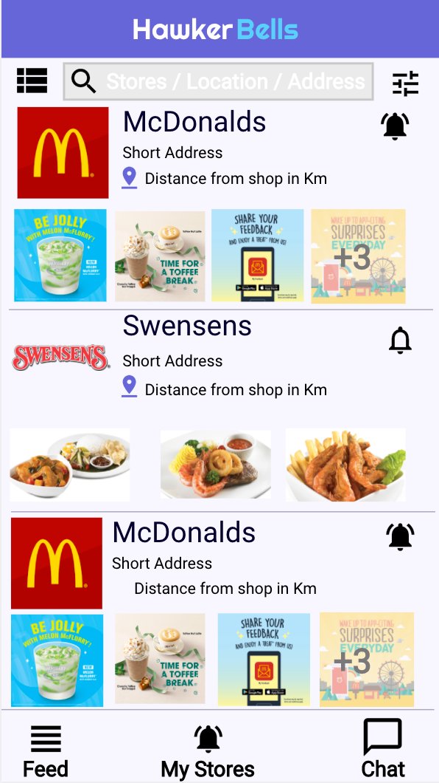
Fig 1: S1 Screen (Store Listing and My Stores Page)

Requirements Definitions

Section/ Requirement ID | Requirement Definition
FR1.0. | Once the users or merchant opens the app, he should be shown first the logo/loading page after which he will be shown the Store Listing screen (S1)
FR1.1 | There should be a search bar which will allow the user to search a store among the listed items.
FR1.2 | The store listing page will list the stores in the order as below  - Latest posted Ads for any stores.  - Near to the current Location (if user Location was on).  - Stores followed by user (if user Location was off, this will first sort )  - All other alphabetical order stores.
FR1.3 | Each store item is an icon and left top corner will have an image of the store, if the image of the store is not available a default image will should be shown.
FR1.4 | Centre top should have the name of the store followed by the address of the store. Then the distance from the store should be shown in Km. e.g. 1.3Km.
FR1.5 | Right Top corner will have the follow store icon. If the Store was liked or followed it should be highlighted as shown in S1 Screen(1st item). If not a followed one then display a empty follow icon, refer to S1 screen (2nd Item).
FR1.6 | Search Bar should be shown in store listing page, My Stores Page and Chat Page.
FR1.7 | The Search bar will have menu icon which will open sliding left menu screen defined in S6 Section.  The Search should allow Store Name or Location or address search.  After the search bar, the filter icon should popup a filter page defined in XX section.
FR1.8 | The scroll should be infinite scroll with a real time refresh.
FR1.9 | The bottom taskbar will have three icons.  - Feed – Which lists all the stores. Clicking should take to S1 Screen.  - My Stores – Which list stores followed by the user. Clicking this should take to S1 Screen only with followed stores.  - Chat –which will take to the chat listing screen defined in S8 Section.

Assumptions

- The Store Master table will be uploaded to DB from backend scripts.

- The no of listing in the listing page will be configurable from XML.

Functional Requirements S2- Store Home page
The Section describes the layout, design and function of store listing screen.

Screen Layout – S2 Store Home Page
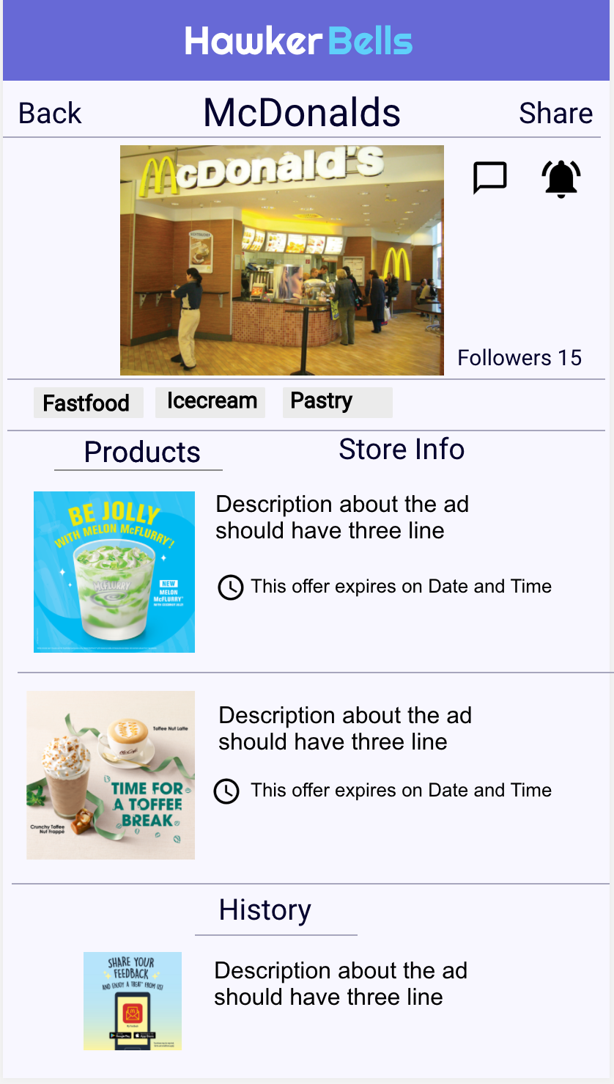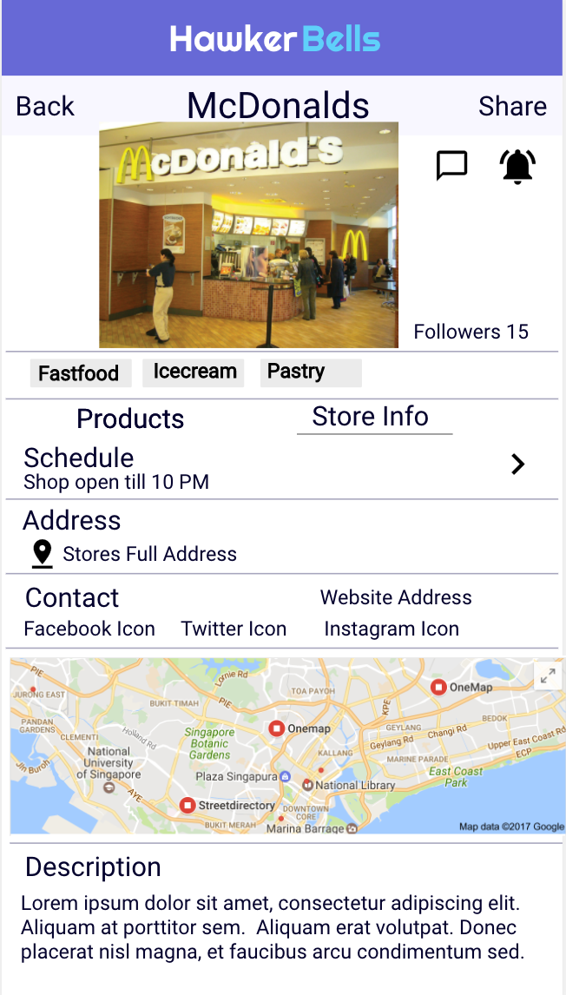

Requirements Definitions
Section/ Requirement ID | Requirement Definition
FR2.0. | On clicking any one of the store in the store listing will show this store home page. Each merchant will be assigned a unique merchant no and store home page will be created.
FR2.1 | The Top Bar should be as mentioned in the above S2 Screen. The store full image should be below the top bar and below it will have follow Icon and Chat Icon.
FR2.2 | Clicking on the Follow Icon it should change to highlighted. If its already followed and the user clicks it then should change to non highlighted.
FR2.3 | Below it we will have categories as shown in the S2 screen. This can be any text. One store can be tied to multiple categories.
FR2.5 | There will be two tabs one for Products and One for Store Info.
FR2.6 | When the user clicks on the product tab, it will show the active Ads and the layout should follow as mentioned in the layout. After the active deals, the history should display the list of ad which he has posted since inception.
FR2.7 | When the user clicks the Info tab, should show the address contact details, website Address, location map and description

Functional Requirements S3- Login Screen
The Section describes the layout, design and function of store listing screen.

Screen Layout
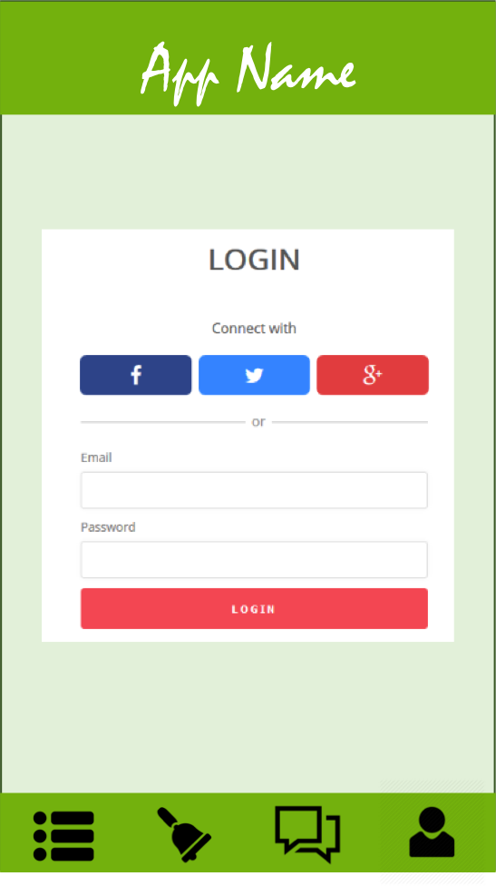

Requirements Definitions
Section/ Requirement ID | Requirement Definition
FR1.0. | The login screen should be selected when the login item is selected from the menu or when a customer user tries to follow any of the shop.
FR1.1 | Logins screen validation including email ID and password should be a industry standard.
FR1.2 | For a new user, there should be signup link which will open the sign up screen. the signup screen will popup

Functional Requirements S4- Signup Screen
The Section describes the layout, design and function of store listing screen.

Screen Layout

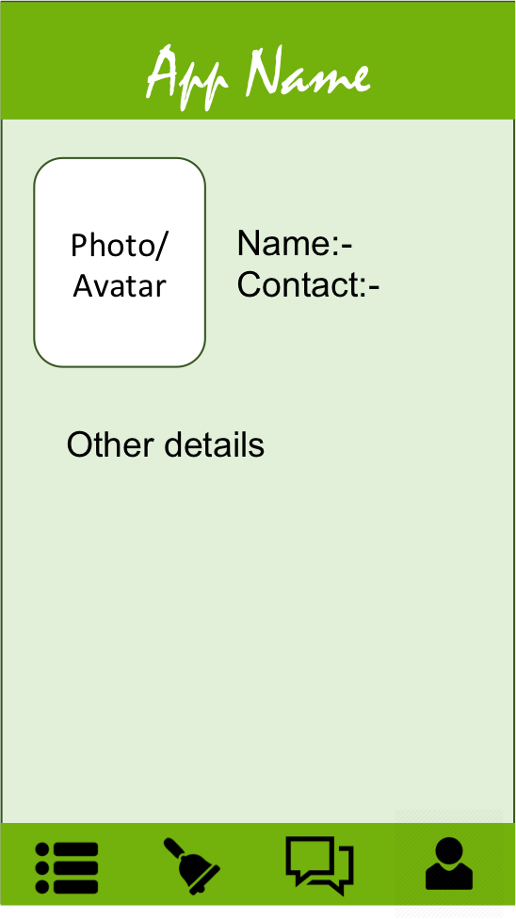

Requirements Definitions
Section/ Requirement ID | Requirement Definition
FR1.0. | The signup screen will have photo box, user name , email Id, password and confirm password.
FR1.1 | User Name, Email ID, Password and Confirm Password as Mandatory.
FR1.1.1 | Photo is an optional field.
FR1.1.2 | There should be save button and the validation should be industry standard and must be elaborated in functional Specification documentation.

Functional Requirements S5- User Screen
The Section describes the layout, design and function of store listing screen.

Screen Layout

Requirements Definitions

Section/ Requirement ID | Requirement Definition
FR1.0.

Functional Requirements S6- Menu and Tool Bar
The Section describes the layout, design and function of store listing screen.

Screen Layout
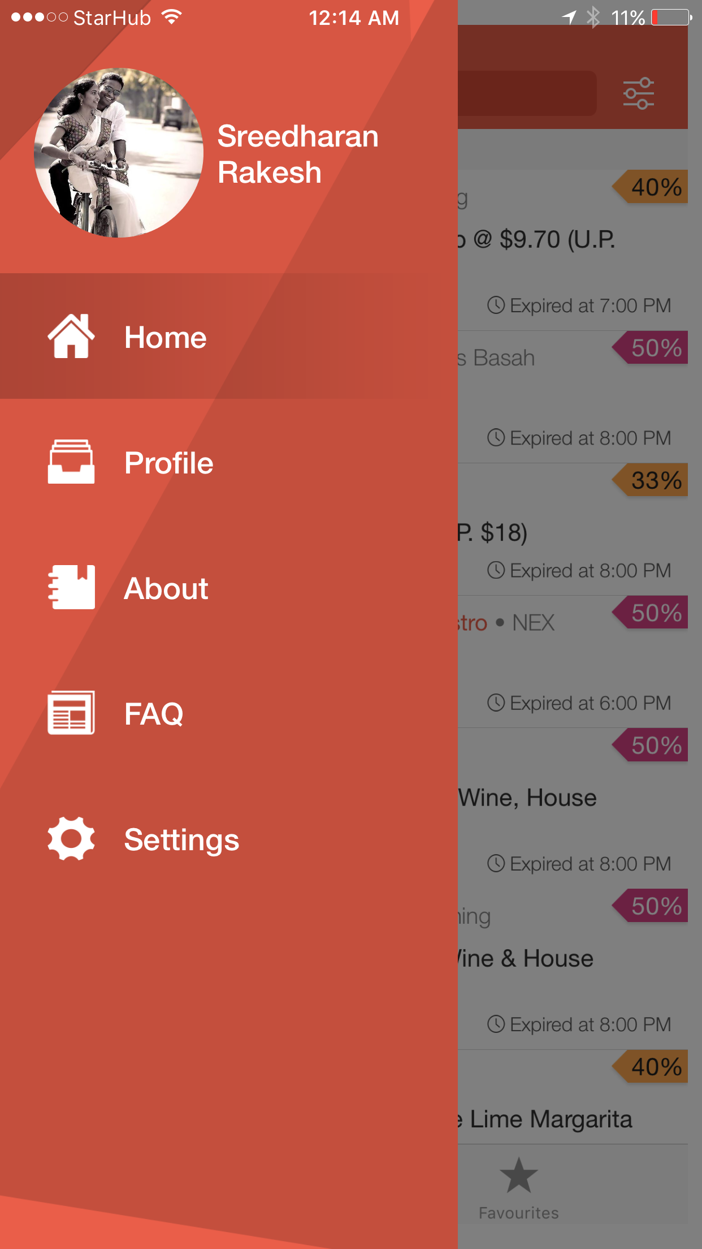

Requirements Definitions
Section/ Requirement ID | Requirement Definition
FR1.0. | There should two menu options  - Top Left Hamburger Icon to open up sliding menu as shown above which will have Picture, Home, Profile, about, FAQ, setting and Logout.  - Footer Menu- Feed, Favorites, Chat and Account
FR1.1 | The First Icon will be menu Icon followed by Notification Icon, Chat Icon
FR1.2 | Notification Icon will have a small number showing the no of notification that the Customer has not Read or viewed. Clicking the notification Icon will open the notification screen S7
FR1.3 | The Chat Icon will show a no of Chat message that are not Read by the customer. Clicking on the chat icon will take you to the Chat screen S8
FR1.4 | The menu will display the photo of the user, followed by the user name and email Id. There will be edit Icon and clicking on which will take to the user screen S5.
FR1.5 | Followed by Email ID, there will Home, search, Login/out.
FR1.6 | Clicking on Home should show him the Store listing page i.e. the landing page.
FR1.7 | Clicking on the search page should show him the search screen which will have a empty list with search box on the top and followed by a cancel button.
FR1.8 | If the customer has already logged in then it will show logout, if he has not logged in yet,then it will show log in.

Functional Requirements S7- Notification Listing
The Section describes the layout, design and function of store listing screen.

Screen Layout
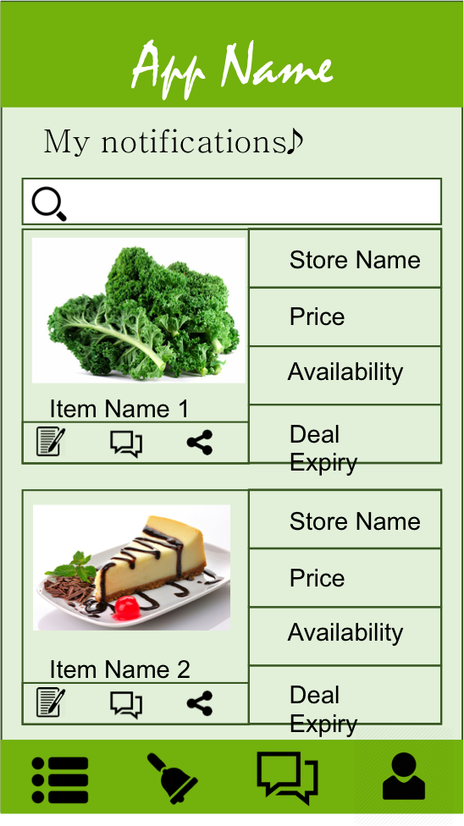

Requirements Definitions

Section/ Requirement ID | Requirement Definition
FR1.0. | This page will be accessed by clicking the notification Icon clicking on the tool bar.
FR1.1 | This will list the history of notification which he has received till the current time in the descending order, those he has read will not be highlighted.
FR1.2 | Clicking the on the same notification Icon should close the notification.

Functional Requirements S8- Chat
The Section describes the layout, design and function of store listing screen.

Screen Layout
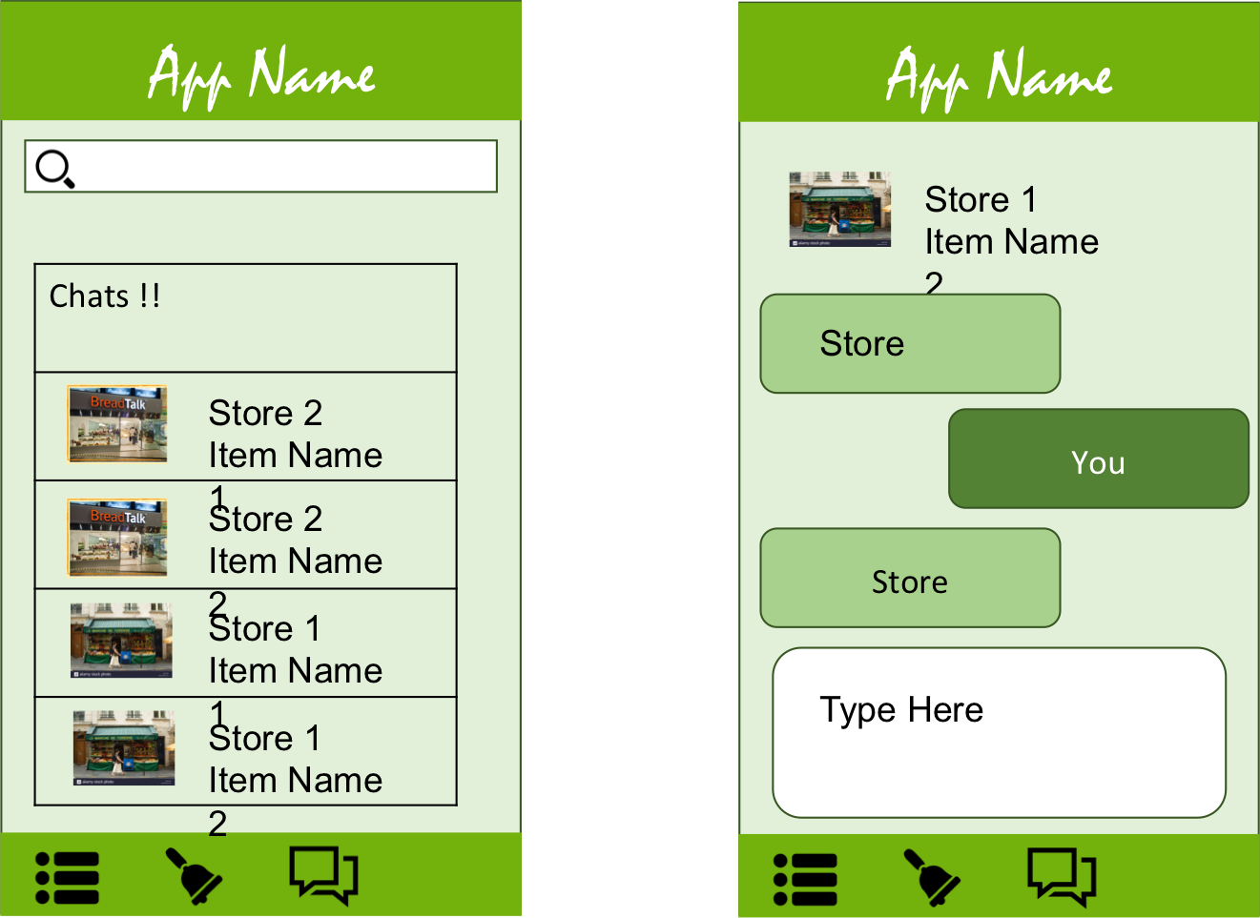

Requirements Definitions
Section/ Requirement ID | Requirement Definition
FR1.0. | On clicking the chat Icon, it should popup a list of chat those were already chat made. Only those for which a chat made with any of his followed shop.
FR1.1 | If there was no chat made earlier, pop up a message to select shop to Chat from the Store listing screen.
FR1.2 | On clicking the any item from the chat list, it should open up a chat window. The chat window should be industry standard. We welcome interesting proposal in the solution.
FR1.3 | The user should be able to send Images and add location to the chat.

Functional Requirements S9- Add Notification (Merchant)
The Section describes the layout, design and function of store listing screen.

Screen Layout
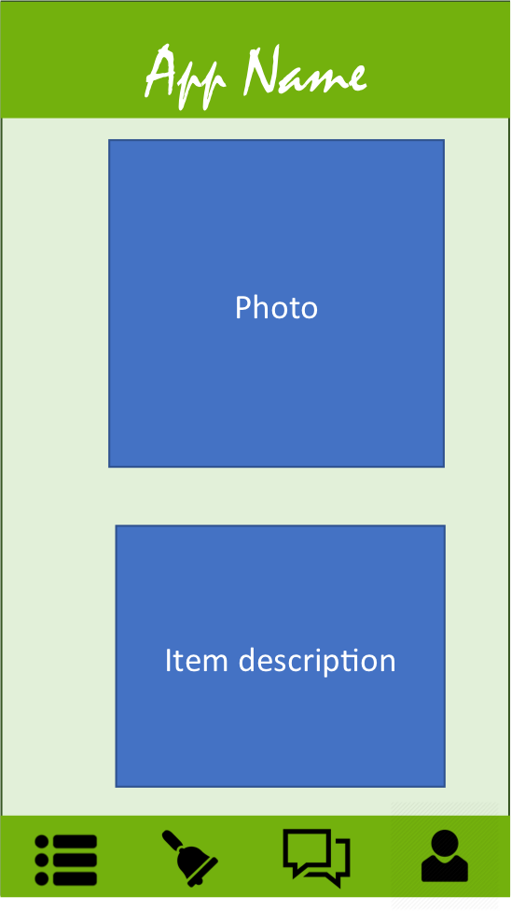

Requirements Definitions
Section/ Requirement ID | Requirement Definition
FR1.0. | This screen is applicable for Merchant Login, this screen can be accessed from the menu item called Add notification which will be shown only for the merchant login.
FR1.1 | There will be special ID and password generated for Merchant from the backend system.
FR1.2 | The notification Icon will be shown for a merchant login.
FR1.3 | The Chat Icon will show the list of chat that he has made so far and also the message he has received. He can choose any one item from the list and start chatting with them.
FR1.4 | A merchant cant initiate a chat with the customer, he can only respond to a customer request.
FR1.5 | A merchant cant follow any other shop, with the merchant ID, he can see the store listing screen but without the Chat Icon, follow Icon or Share Icon in the store listing screen
FR1.6 | A merchant can only add /edit / delete notification and respond to a chat and edit information on the store page. He is the only person who edit the store Admin page.
FR1.7 | The Add notification screen will have photo box, short Message, Ad description. There will also be a start date and end Date notification. There will be check box to send notification on everyday.
FR1.8 | For any add he can only post a ad for a current date or future date. The future start date must be within a 31 days from the current date. The end date must be less than 7 days from the Start Date. The Start date and End Date can be same.
FR1.9 | Repeat daily checkbox – If this check box is ticked then the notification should be sent every day for the no of day he configure the notification. The notification default time is set to 6:00 PM SGT.
FR2.0 | Photo is not mandatory, but the short message, message Description and Start date and end Date is mandatory. Repeat Daily check box is not mandatory.

OTHER REQUIREMENTS

Interface Requirements
The Mobile Application should be able to view in Mobile and Ipad browsers including IE, Chrome, Firefox and Safari. Should be supported in Mobile app OS platform such as Android, IOS and Windows.

Software Interfaces
The UI/UX should be interactive and intuitive.
The screen should be well designed without any latency in touch and other operations in the app.
If the mobile data is not there, the app should prompt a proper error message to try when the internet connection is available.
The app should not hang when performing any operation.

Security and Privacy

Error Handling

Validation Rules

Conventions/Standards
Basic Mobile Application Standard are expected to be followed.

APPENDIX A - GLOSSARY
[Define terms, acronyms, and abbreviations used in the FRD.]

